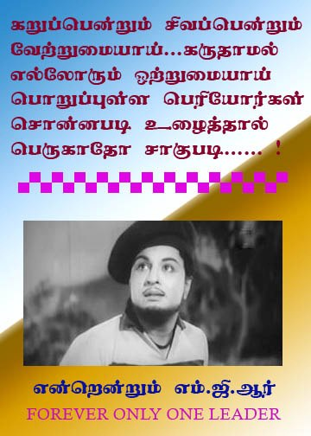

**DEVISRI**

**JEYASRI**

**NURUL ADRINA**

**PRISVEEN**

**MOHD PUTRA FARIS**

**NIVESHAN**

**RAJESWARAN**

**MOHD PUTRA FAZRUL**

**MOHD AIMAN**

**EDWIN**

**MOHD ZUL**

**MOHD HAIR**

**JEGATHESWARRY**

**VETANAYAGAM**